Pirouette Academy of Dance – Health & Safety Policy
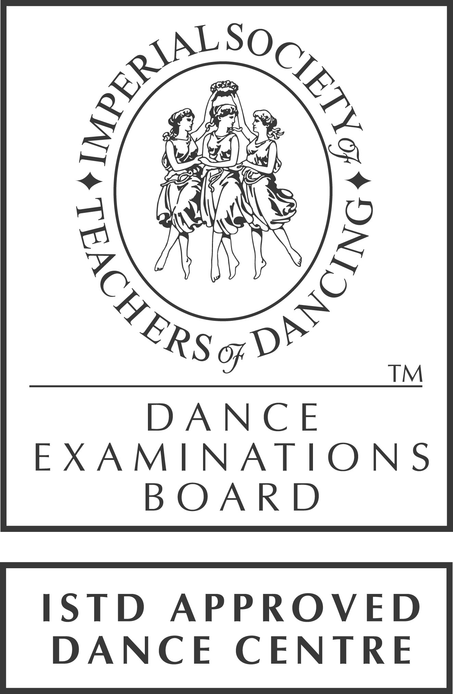
Our statement of general policy is:

To provide adequate control of health and safety risks arising from our work activities
To consult with our employees/volunteers on matters affecting their health and safety
To provide information and instruction for employees/volunteers
To ensure all employees/volunteers are competent to do their tasks
To prevent accidents
To maintain safe and healthy working conditions
To provide and maintain safe working equipment
To regularly review and revise this policy as necessary on a regular basis
Pirouette Academy of Dance ensures that classes are of a size appropriate to the levels and techniques being taught and the space being used. Students in each class should be of compatible age and/or standard.
We are aware of developments in Child Protection legislation and undertake Criminal Records Bureau enhanced disclosure as required.
Pirouette will ensure that teaching facilities are adequately maintained and provide:
- suitable flooring appropriate to the technique taught, with a clean, safe surface; to minimise the risk of injury
- adequate heating levels and ventilation
- suitable, secure and safe area for changing
Any potential safety hazards must be reported the Principal of the School, Jayne Wing

Risk Assessment - Facility
While it is the responsibility of the United Reform Church to ensure that risk assessments are carried out throughout the whole building, Pirouette Academy of Dance will also carry out a private Risk Assessment. Any risks that are found which can be related directly to the School’s personal equipment or property should be reported to the principal and will be dealt with appropriately. Any risk found within the building, but not related directly to the school, should be reported to the Caretaker of the United Reform Church.

Risk Assessment - School’s Property
- Child Plug Protectors are used in all un-used plugs due to teaching children of under 4 years of age.
- The floor is securely fixed to avoid the risk of tripping.
- Sound system leads & equipment leads are taped down over areas that pupils may walk across, to avoid tripping
- Speakers & iPods will have electrical maintenance checks yearly
- The Ballet Barre is maintained by the School Principal, and will be checked at the end of each term for safety measures.
- Small children are not allowed into the kitchen area.

Fire Risk
The United Reform Church is responsible for maintaining all fire extinguishers, and fire fighting equipment.
There are fire instructions posted on all Notice Boards and by the main door – all staff and students are made aware of this and are to familiarise themselves with the instructions.
There are several fire extinguishers within the building: Attached to the wall by the main door, Kitchen Area, and in the changing room.
A fire alarm is installed within the building.

Accidents & First Aid
Pirouette Academy of Dance has a private accident Logbook for any pupils that injury themselves whilst attending dance classes. All accident must be reported and recorded in the accident book.
Injuries reported to the Principal Jayne Wing or to the Administrator Julie Robinson
First Aid Box is kept in the changing room cupboard
Parents must inform principal/teacher if child has medical condition such as asthma.

Public Insurance Liability
The Principal of the school, Jayne Wing has public liability insurance and the certificate is displayed on the notice board by the changing room. Any locum teacher who teaches classes will be either covered via this insurance, or will have their own personal insurance. Pirouette Academy of Dance will not employ anyone to teach for the school that does not have the correct insurances required.

Noise
Although music is played within the dance school, the volume is kept at a level where the teacher’s voice can be heard. At times the music may be completely turned down.

Smoking Policy
Smoking is not permitted anywhere within the building. There are numerous signs posted throughout.

Drugs & Alcohol Policy
Pirouette Academy of Dance has a strict no drugs & alcohol policy. Any pupil or teacher found using drugs or alcohol whilst attending classes or working at the school, will be presented with a verbal warning, and information on where to obtain help regarding this problem. Parents will be advised if the pupil is under the age of 18 years.

Pirouette Academy of Dance will make sure that any teacher involved within the school, is made aware of all Health & Safety Polices, and who they should report to should the issue arise for any of the above matters.

Signed on behalf of Pirouette Academy of Dance

………………………………………………………
Jayne Wing
Principal Date: ………………………………..
To be reviewed: AUGUST 2014

